Cloud IAM: Qwik Start
45 minutes1 Credit

Rate Lab

GSP064

Overview
Google Cloud's Identity and Access Management (IAM) service lets you create and manage permissions for GCP resources. Cloud IAM unifies access control for GCP services into a single system and provides a consistent set of operations. In this hands-on lab you learn how to assign a role to a second user and remove assigned roles associated with Cloud IAM. More specifically, you sign in with 2 different sets of credentials to experience how granting and revoking permissions works from GCP Project Owner and Viewer roles.

Prerequisites
This is an introductory level lab. Little to no prior knowledge of Cloud IAM is expected. Experience with Cloud Storage is helpful to complete the tasks in this lab, but is not required. Make sure that you have a file in .txt or .html available. If you are looking for more advanced practice with Cloud IAM, be sure to check out the following lab:
- IAM Custom Roles
Once you're prepared, scroll down and follow the steps to get your lab environment set up.

Setup for two users
As mentioned earlier, this lab provides two sets of credentials to illustrate IAM policies and what permissions are available for specific roles.
In the panel on the left-hand side of your lab, you see a list of credentials that resembles the following:
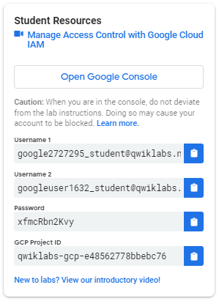
Notice that there are two usernames: Username 1 and Username 2. These represent identities in Cloud IAM, each with different access permissions allocated to them. These GCP "roles" set constraints on what you can and cannot do with GCP resources in the project you've been allocated.

Sign in to GCP Console as the first user
- Click on the Open Google Console button. This opens a new browser tab. If you are asked to Choose an account, click Use another account.
- The GCP sign in page opens. A Sign in page opens—copy and paste the Username 1 credential that resembles googlexxxxxx_student@qwiklabs.net into the "Email or phone" field.
- Copy the password from the "Connection Details" panel and paste into the Google Sign in password field.
- Click Next and then Accept the terms of service. The Google Cloud Platform Console opens. Agree to the terms of service and check No for email updates:
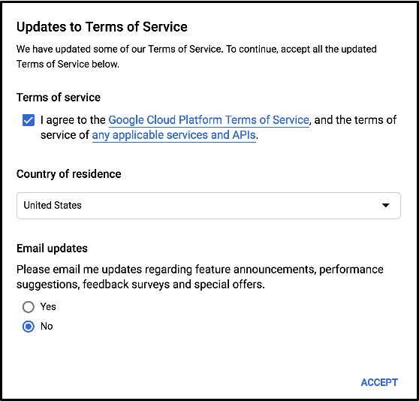

Sign in to GCP Console as the second user
- Click on the Open Google Console button again. A new browser tab opens, if you are asked to Choose an account, click Use another account.
- The GCP sign in page opens. Copy and paste the Username 2 credential that resembles googlexxxxxx_student@qwiklabs.net into the Email or phone field.
- Copy the password from the Connection Details panel and paste into the Google Sign in password field.
- Click Next and then Accept the terms of service. The Google Cloud Platform Console opens. Agree to the terms of service and check No for email updates:
You should now have two GCP Console tabs open in your browser—one signed in with Username 1 and the other with Username 2.

View or reset the user in a browser tab
Occasionally, a user is overwritten in a browser tab or you may be confused about which user is signed into which browser tab.
To view which user in signed into a browser tab, hover over your Avatar to view your username in that browser tab.
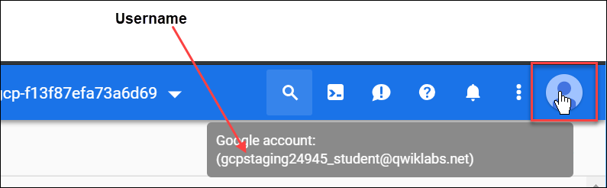
To reset which user is signed into a browser tab:
- Click your Avatar and click Sign out to sign out.
- In the Connection Details panel, click Open Google Console and sign back in using the appropriate Username and Password.

The IAM console and project level roles
- Return to the Username 1 GCP Console page.
- Select Navigation menu > IAM & admin > IAM. You are now in the "IAM & admin" console.
- Click +ADD button near the top of the page and explore the project roles associated with Projects by clicking on the "Select a role" dropdown menu:
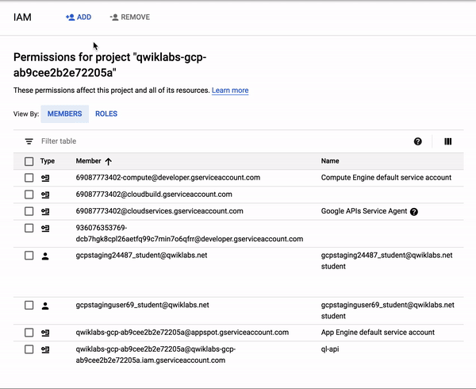
You should see Browser, Editor, Owner, and Viewer roles. These four are known as primitive roles in GCP. Primitive roles set project-level permissions and unless otherwise specified, they control access and management to all GCP services.
The following table pulls definitions from the GCP roles documentation, which gives a brief overview of browser, viewer, editor, and owner role permissions:
Role Name | Permissions
roles/viewer | Permissions for read-only actions that do not affect state, such as viewing (but not modifying) existing resources or data.
roles/editor | All viewer permissions, plus permissions for actions that modify state, such as changing existing resources.
roles/owner | All editor permissions and permissions for the following actions:  - Manage roles and permissions for a project and all resources within the project.  - Set up billing for a project.
roles/browser (beta) | Read access to browse the hierarchy for a project, including the folder, organization, and Cloud IAM policy. This role doesn't include permission to view resources in the project.
Since we were able to manage roles and permissions for this project, Username 1 has Project owner permissions.
- Click CANCEL to exit out of the "Add member" panel.

Explore editor roles
Now switch to the Username 2 console.
- Navigate to the IAM & admin console select Navigation menu > IAM & admin > IAM.
- Search through the table to find Username 1 and Username 2 and examine the roles they are granted. You should see something like this:
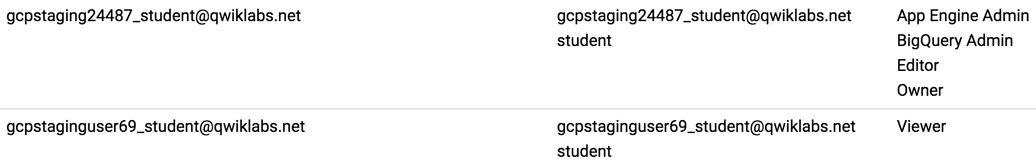
You should see:
- Username 2 has the "Viewer" role granted to it.
- The +ADD button near the top is grayed out—if you try to click on it you get the following message:
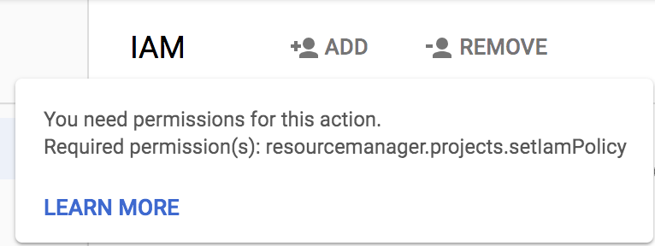
This is one example of how IAM roles affect what you can and cannot do in GCP.
- Switch back to the Username 1 console for the next step.

Prepare a resource for access testing
Ensure that you are in the Username 1 console.

Create a bucket
- Create a GCS bucket with a unique name. From the Console, select Navigation menu > Storage > Browser.
- Click Create bucket.
Note: If you get a permissions error for bucket creation, sign out and then sign in back in with the Username 1 credentials.
- Update the following fields, leave all others at their default values:
Property | Value
Name: | globally unique name (create it yourself!)
Default storage class: | Multi-Regional
Note the bucket name. You will use it in a later step.
- Click Create.
Note: If you get a permissions error for bucket creation, sign out and then sign in back in with the Username 1 credentials.

Upload a sample file
- On the Bucket Details page click Upload files button.
- Browse your computer to find a file to use. Any text or html file will do.
- Click on the three dots at the end of the line containing the file and click Rename.
- Rename the file ‘sample.txt'.
- Click Rename.
Click Check my progress to verify the objective.
Create a bucket and upload a sample file
Check my progress

Verify project viewer access
- Switch to the Username 2 console.
- From the Console: select Navigation menu > Storage > Browser. Verify that this user can see the bucket.
Username 2 has the "Viewer" role prescribed which allows them read-only actions that do not affect state. This example illustrates this feature—they can view Cloud Storage buckets and files that are hosted in the GCP project that they've been granted access to.

Remove project access
Switch to the Username 1 console.

Remove Project Viewer for Username 2
- Select Navigation menu > IAM & admin > IAM. Then click the pencil icon next to Username 2.
You may have to widen the screen to see the pencil icon.
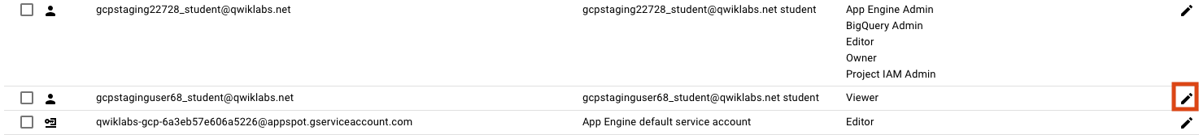
- Remove Project Viewer access for Username 2 by clicking the trashcan icon next to the role name. Then click SAVE.
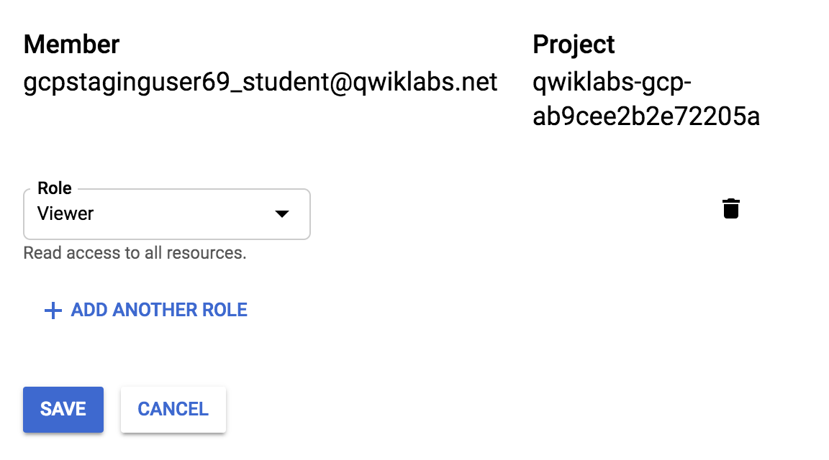
Notice that the user has disappeared from the list! The user has no access now.
Note: It can take up to 80 seconds for such a change to take effect as it propagates. Read more here.

Verify that Username 2 has lost access
- Switch to Username 2 console. Ensure that you are still signed in with Username 2's credentials and that you haven't been signed out of the project after permissions were revoked. If are signed out, sign back in with the proper credentials.
- Select Navigation menu > Home.
- Navigate back to Cloud Storage by selecting Navigation menu > Storage > Browser.
You should see a permission error that resembles the following
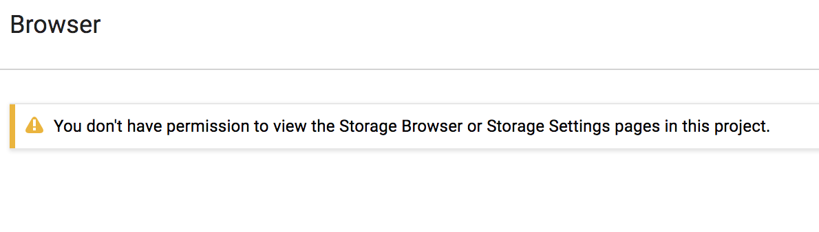
Note: As mentioned before, it can take up to 80 seconds for permissions to be revoked. If you haven't received a permission error, wait a 2 minutes and then try refreshing the console.
Click Check my progress to verify the objective.
Remove project access
Check my progress

Add Storage permissions
- Copy Username 2 name from the Qwiklabs "Connection Details" panel.
- Switch to Username 1 console. Ensure that you are still signed in with Username 1's credentials. If you are signed out, sign back in with the proper credentials.
- In the Console, select Navigation menu > IAM & admin > IAM.
- Click + ADD to then paste the Username 2 name into the New members field.
- In the Roles field, select Storage > Storage Object Viewer from the drop-down menu.
- Click SAVE.

Verify access
- Switch to the Username 2 console.
The Username 2 doesn't have Project Viewer role so that user can't see the project or any of its resources in the Console. However, this user has specific access to Cloud Storage. Let's check it out now.
- Click the Activate Cloud Shell icon to open the Cloud Shell command line.

- Open up a Cloud Shell session and then enter in the following command, replacing [YOUR_BUCKET_NAME] with the name of the bucket you created earlier:
gsutil ls gs://[YOUR_BUCKET_NAME]
- You should receive a similair output:
gs://[YOUR_BUCKET_NAME]/sample.txt
- As you can see, you gave Username 2 view access to the Cloud Storage bucket.
Click Check my progress to verify the objective.
Add Storage permissions
Check my progress

Congratulations!
You've completed the lab. In this lab you exercised granting and revoking Cloud IAM roles to a user.

